**User (userID, name, password, tel, log_status, email, user_rank, vip_days_remaining)**

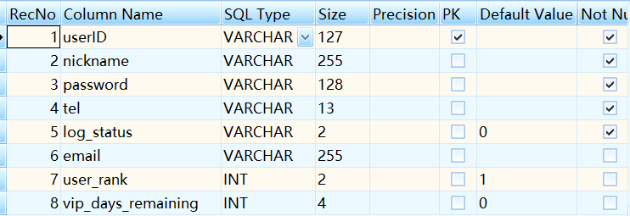

**QQ_main (userID, QQ_num)**

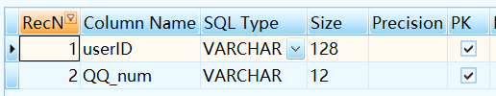

**QQ_trust (userID, QQ_trust_num)**

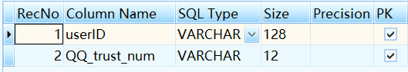

**Wechat (userID, WX_id)**

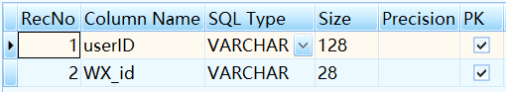

*//关键词*

**QQ_keyWords_set (userID, QQ_id, keyword, apply_area, active_time)**

**//QQ_用户自定义关键词**

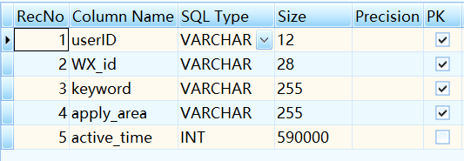

**QQ_group_msg (userID, QQ_id, keyword, source_QQid, src_QQgrp, msg_time, msg) //QQ群关键词提醒**

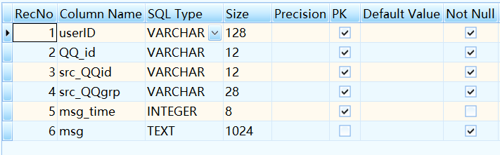

**WX_keyWords_set (userID, WX _id, keyword, apply_area, active_time)**

**// WX_用户自定义关键词**

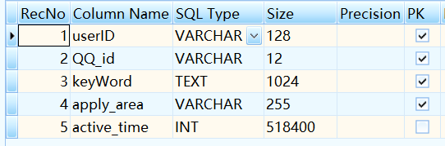

**WX_group_msg (userID, WX _id, keyword, source_ WX_id, src_WXgrp, msg_time, msg )**

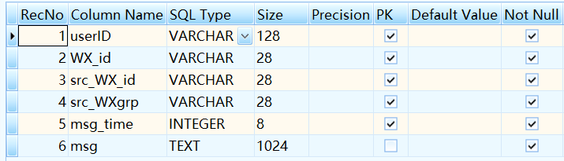

**//消息群发模板**

**Msg_model (No, userID, type, msg_m)**

